**Carousell coding Round - Reddit**

**Scope:**

To develop a Reddit replica, facilitating users to add topics, upvote and downvote them and search for them based on category.

**Target Audience:**

End users using the application.

**Functionality:**

The application caters to the following purposes:

1. Add a user.
2. Allow users to add topics.
3. Allow users to search for topics based on Categories.
4. Navigate between Top 20/ Most recent/ All topics.

**Sample Input/Output:**

**HomePage:**

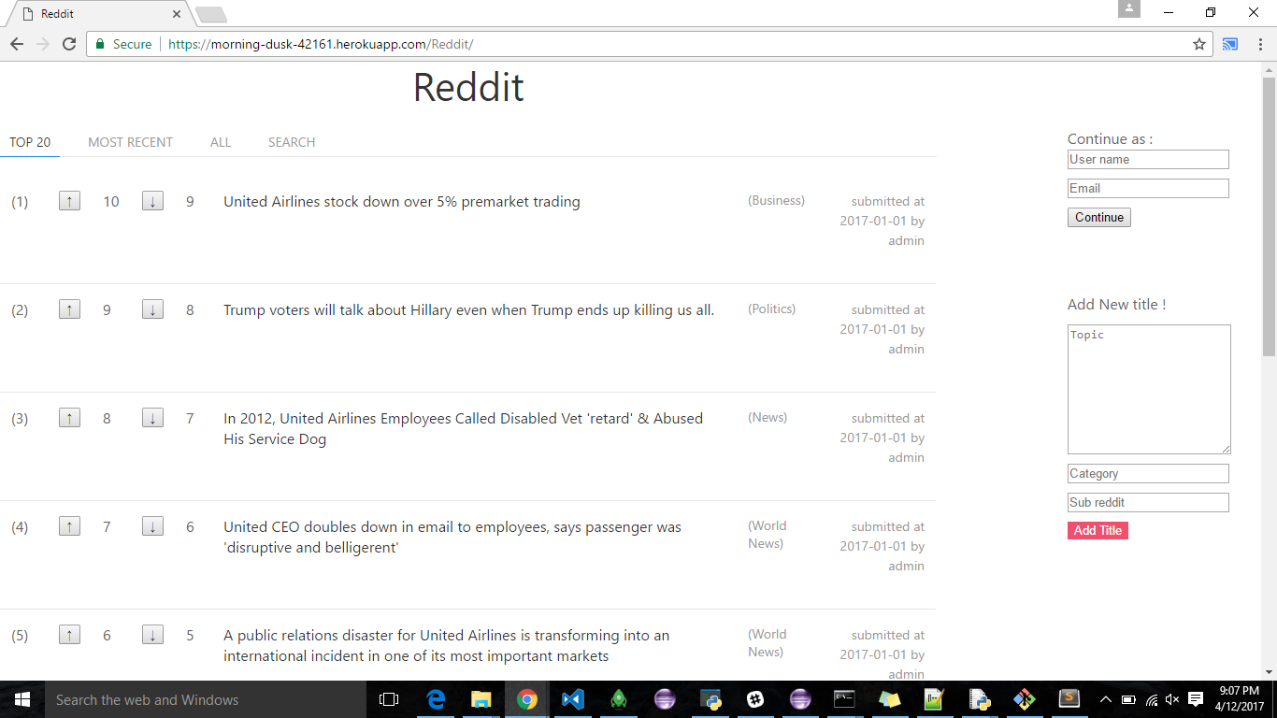

**Add Topic without adding User:**

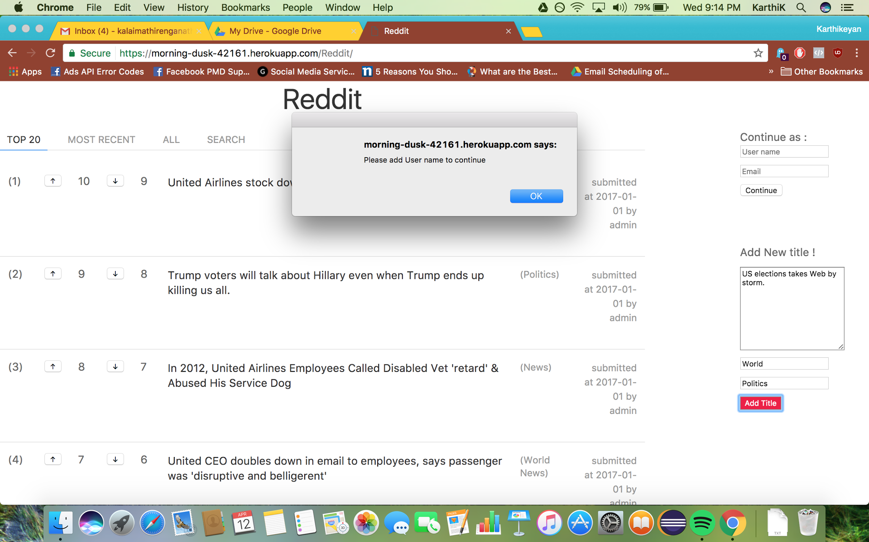

**Add User :**

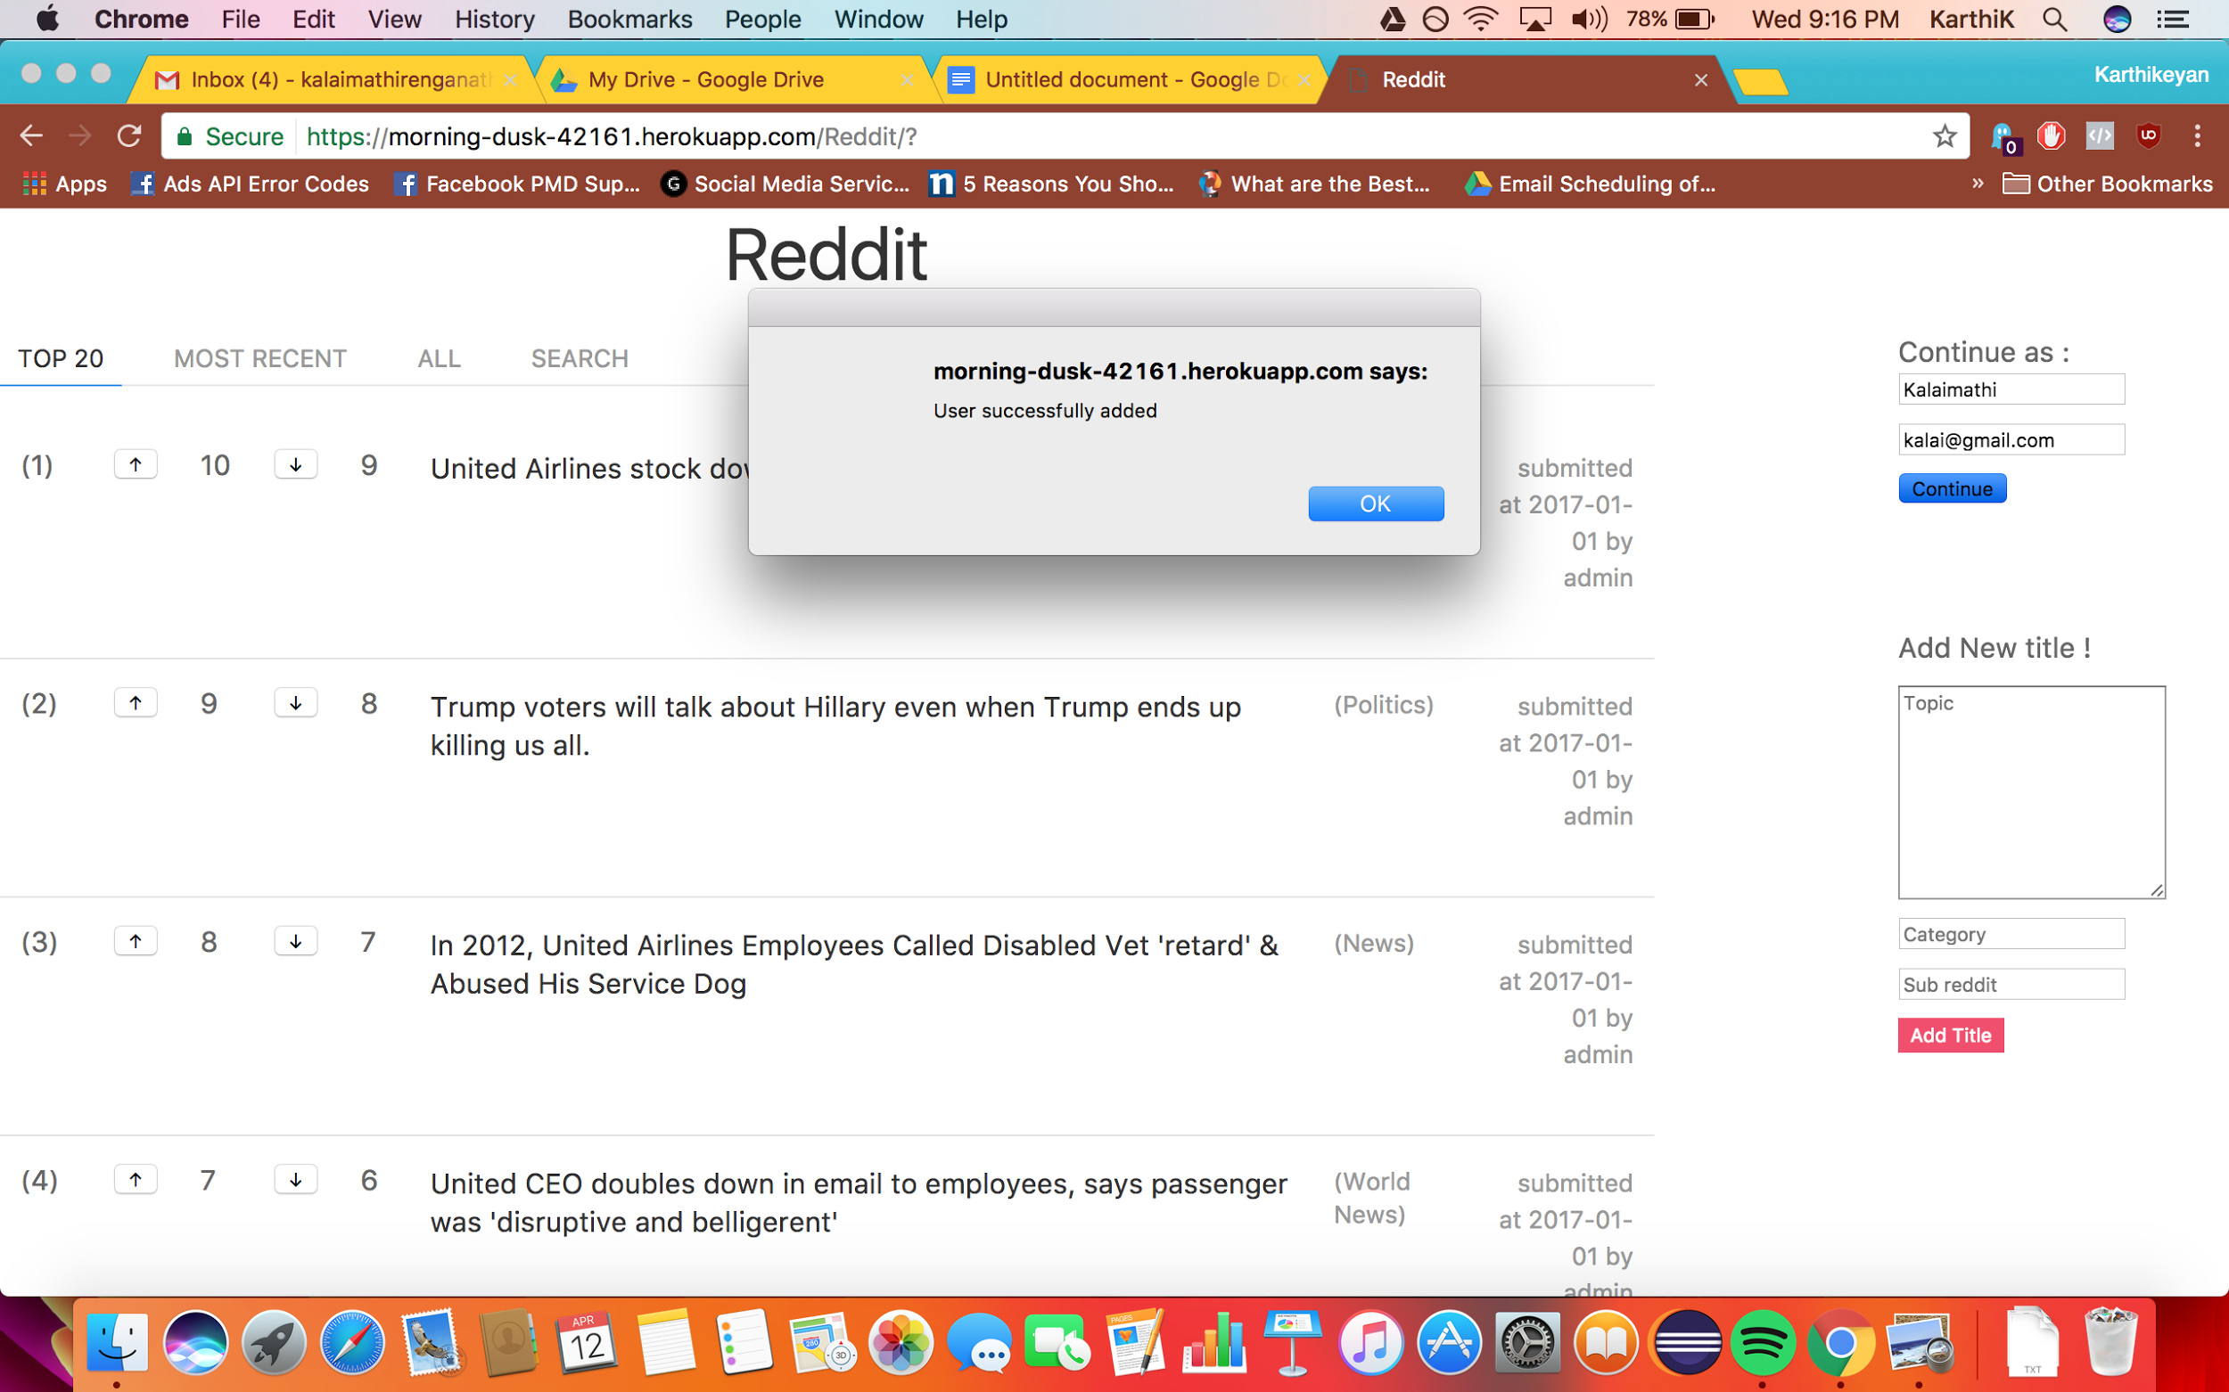

**After user is added:**

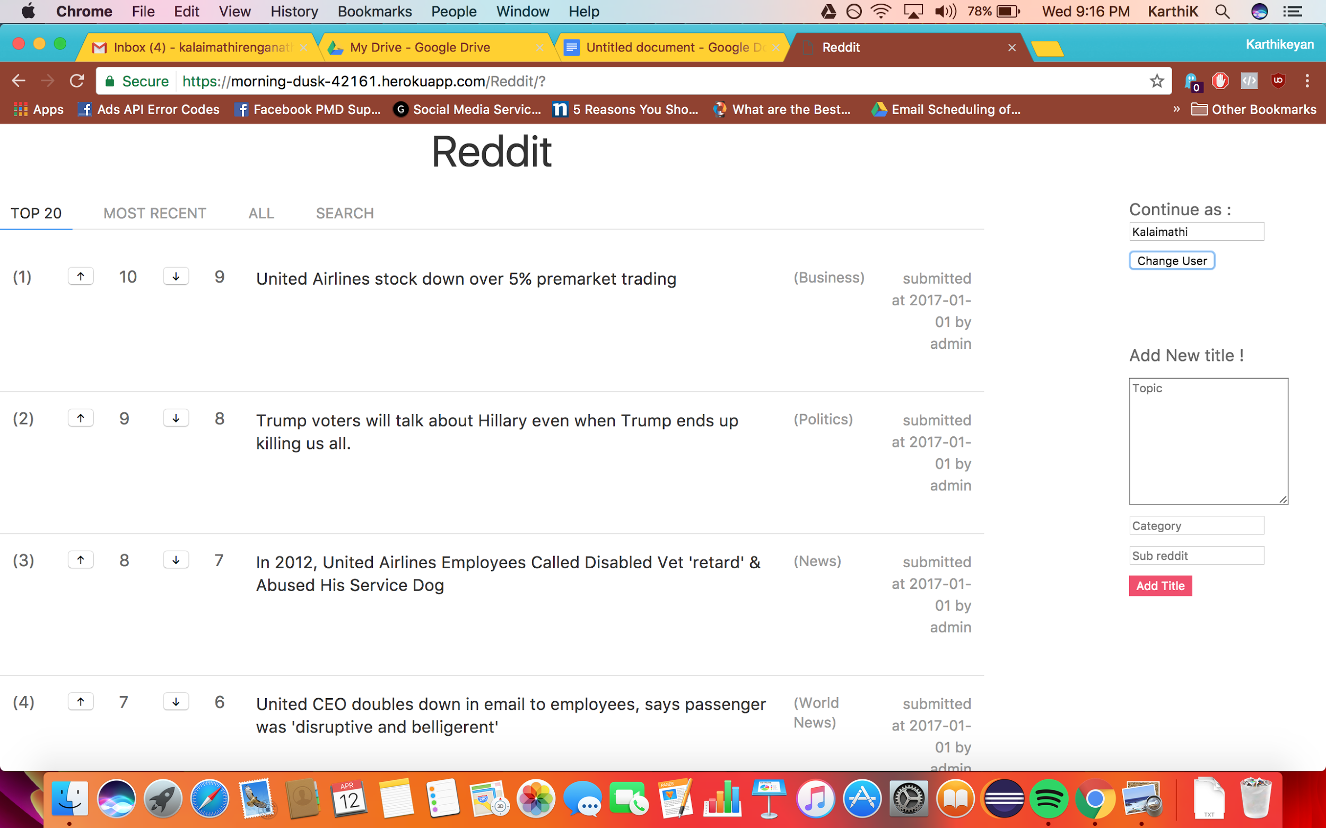

**Change user:**

If that button is clicked, the same as adding user form is rendered.

**Top 20(descending order of upvotes):**

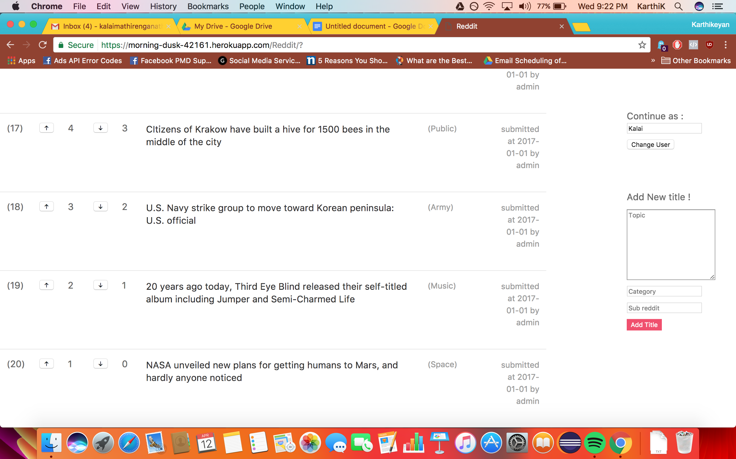

**Add topic:**

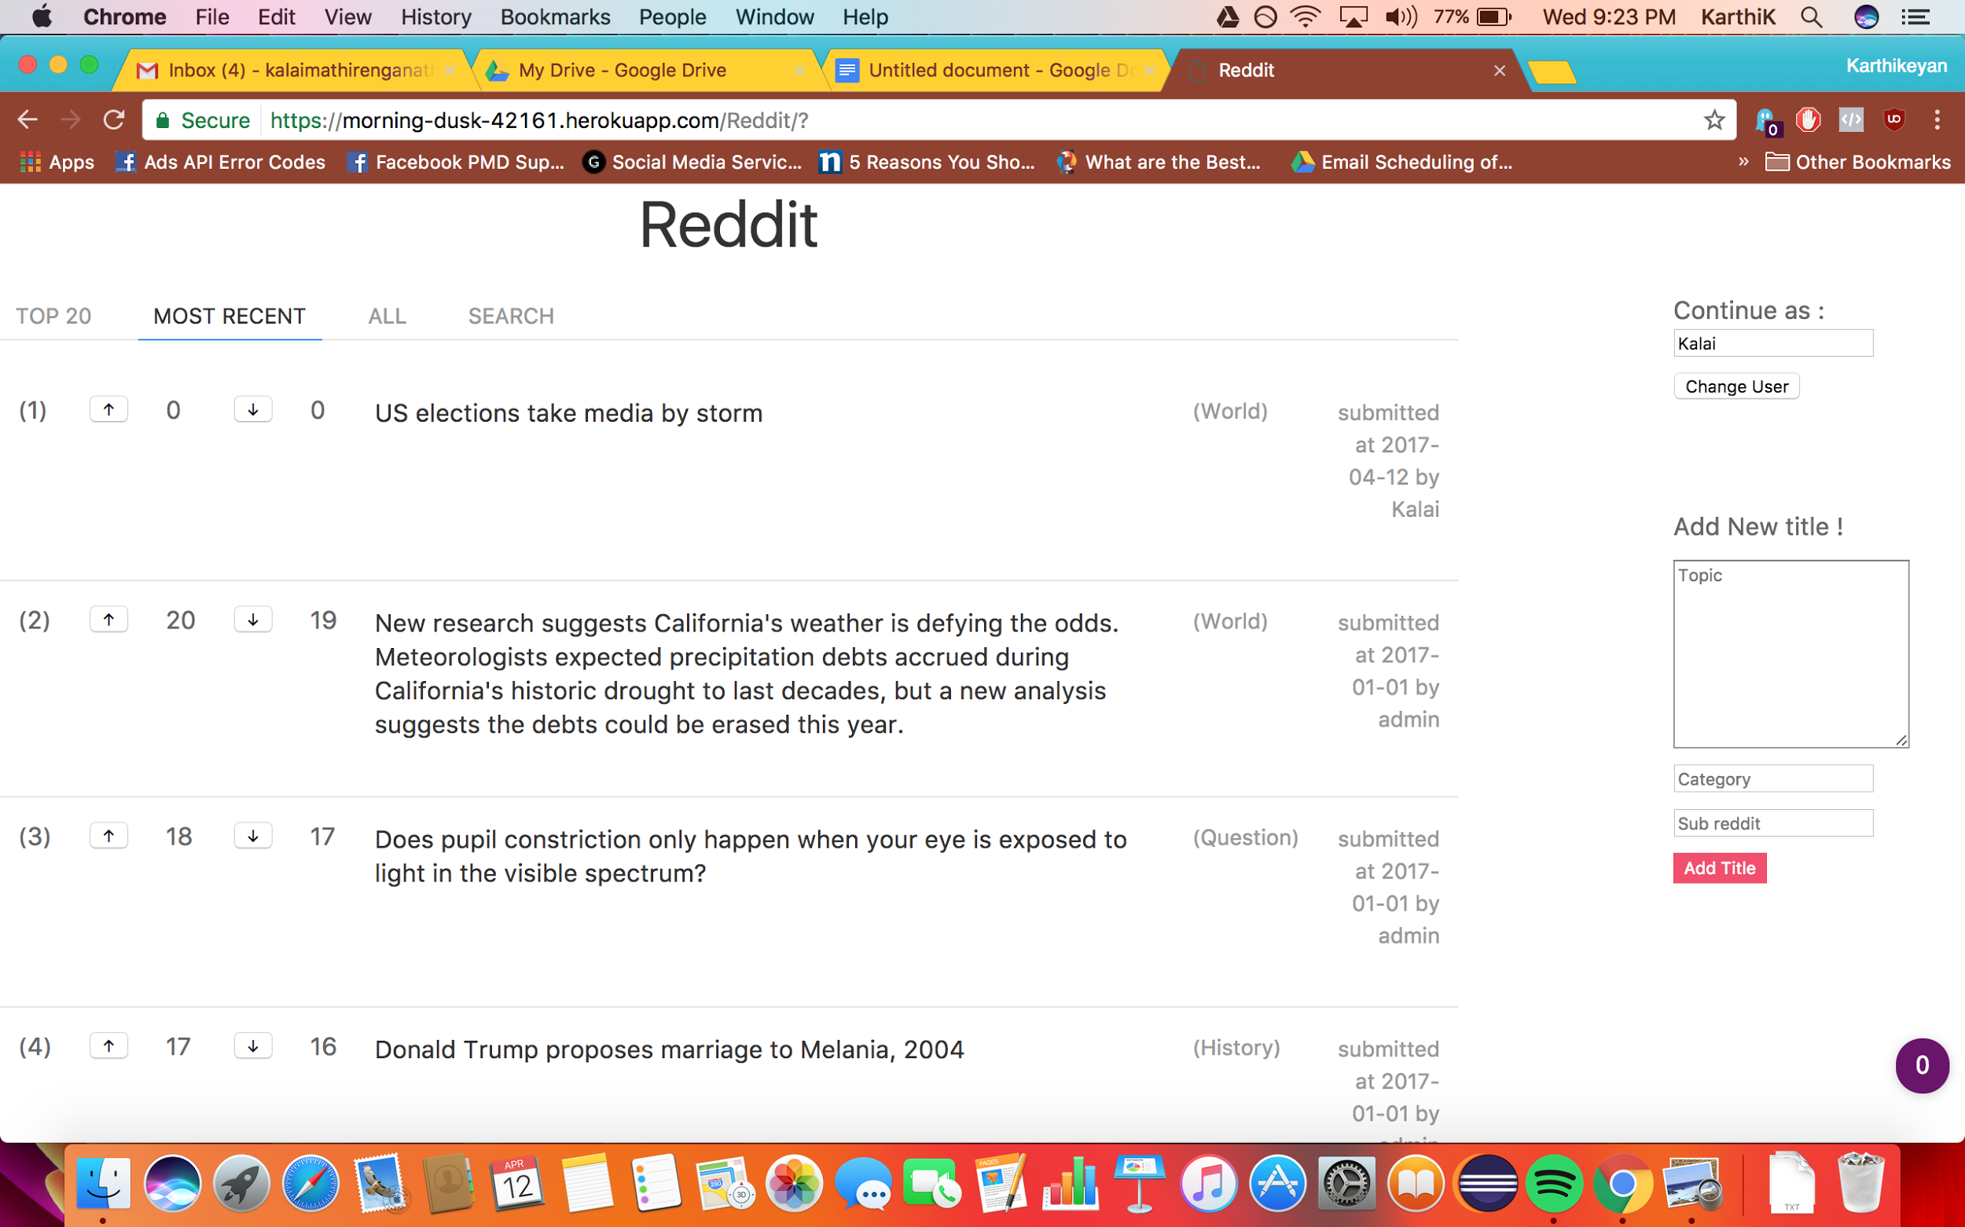

**Upvotes:**

**(before)**

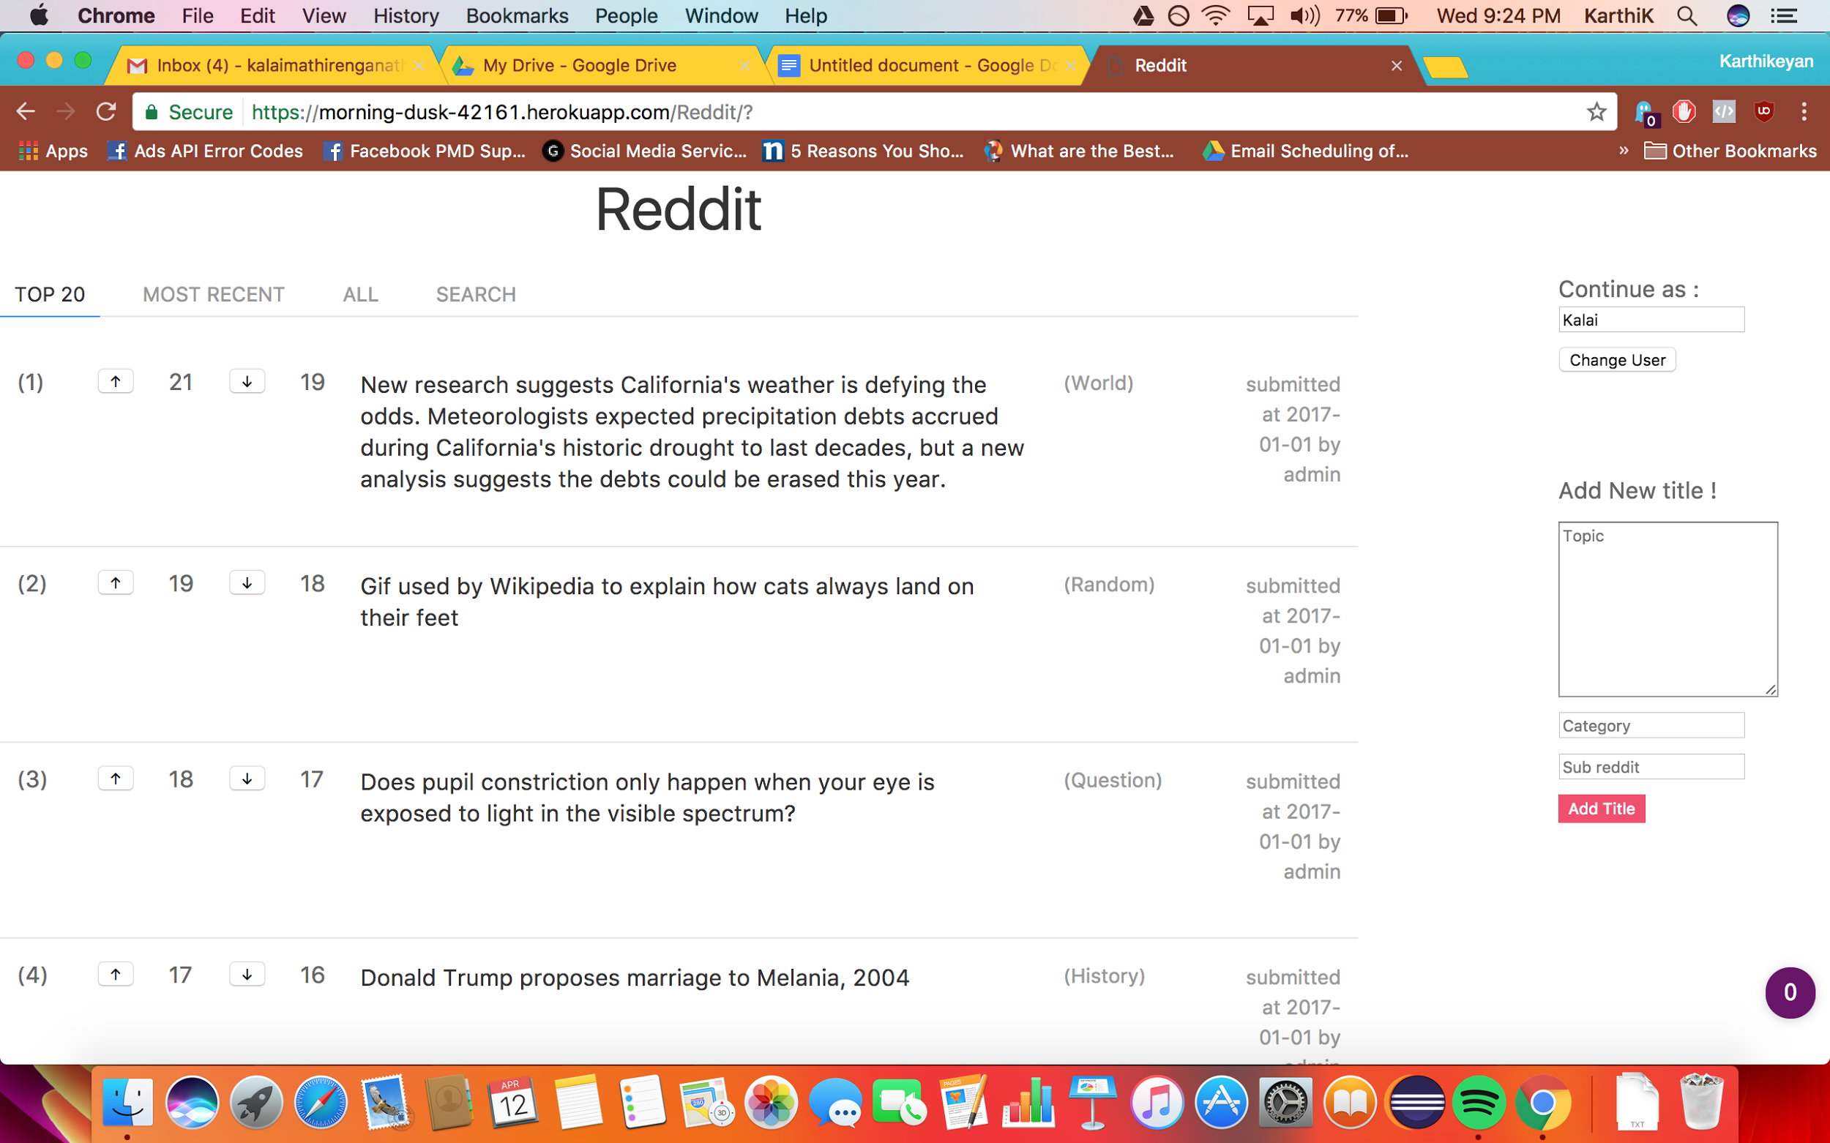

**(after) note 2 topic**

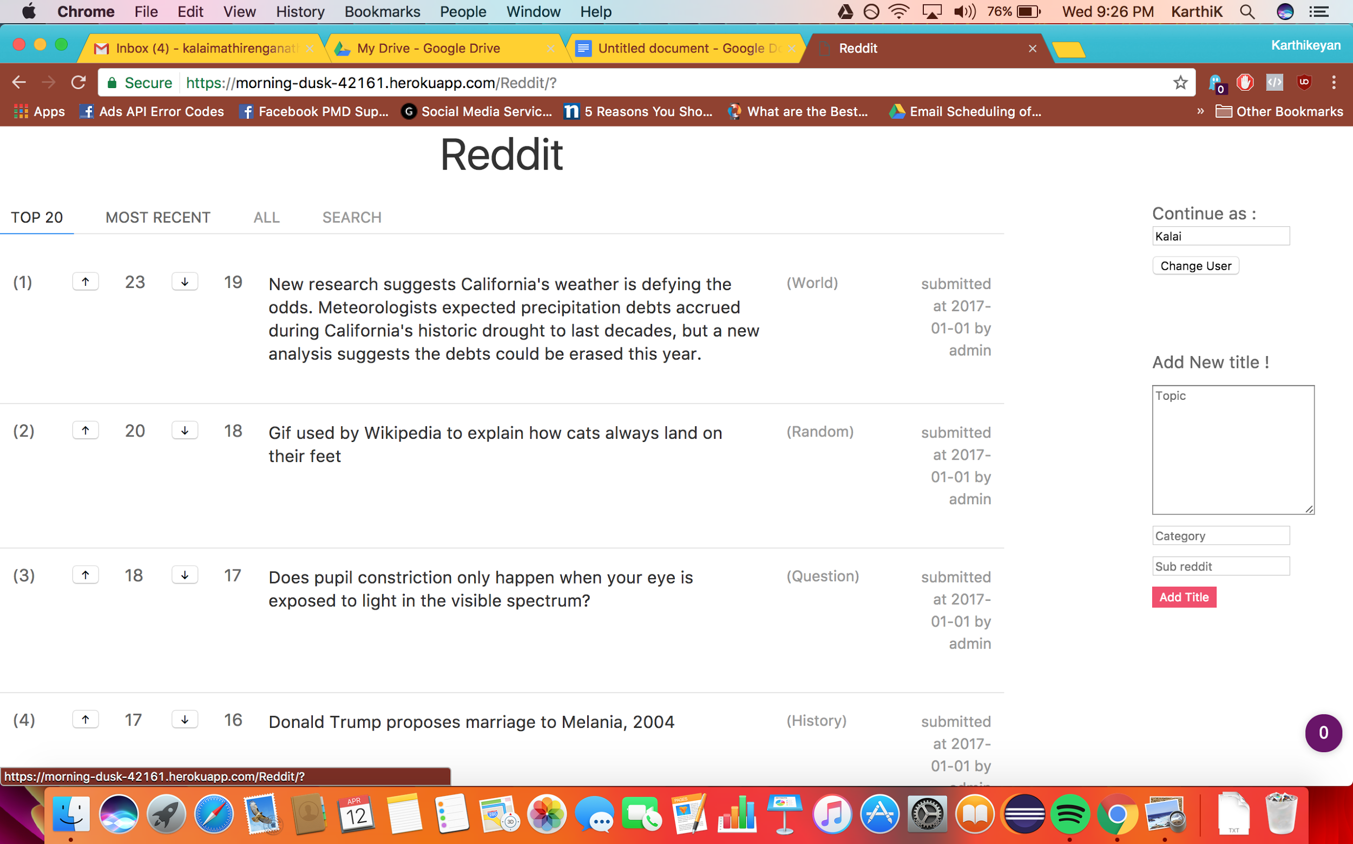

**Downvotes ( note topic 1)**

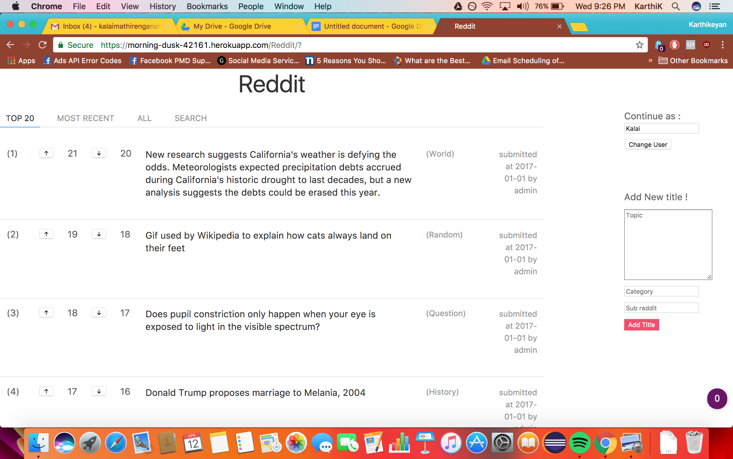

**All - displaying more than 20**

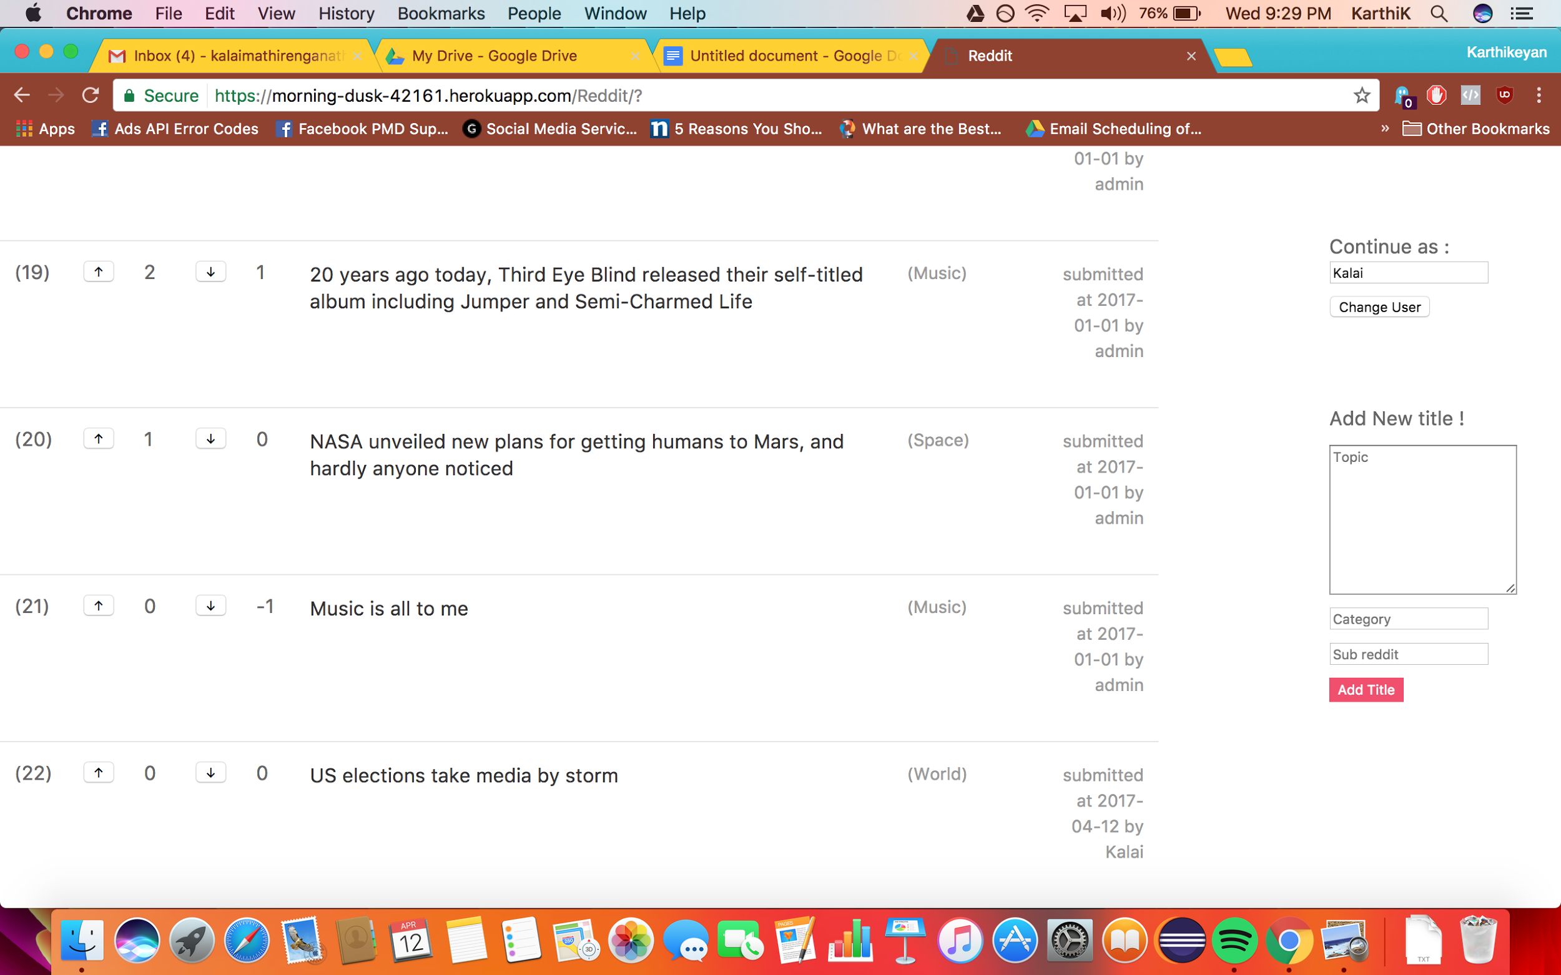

**Search**

**Form**

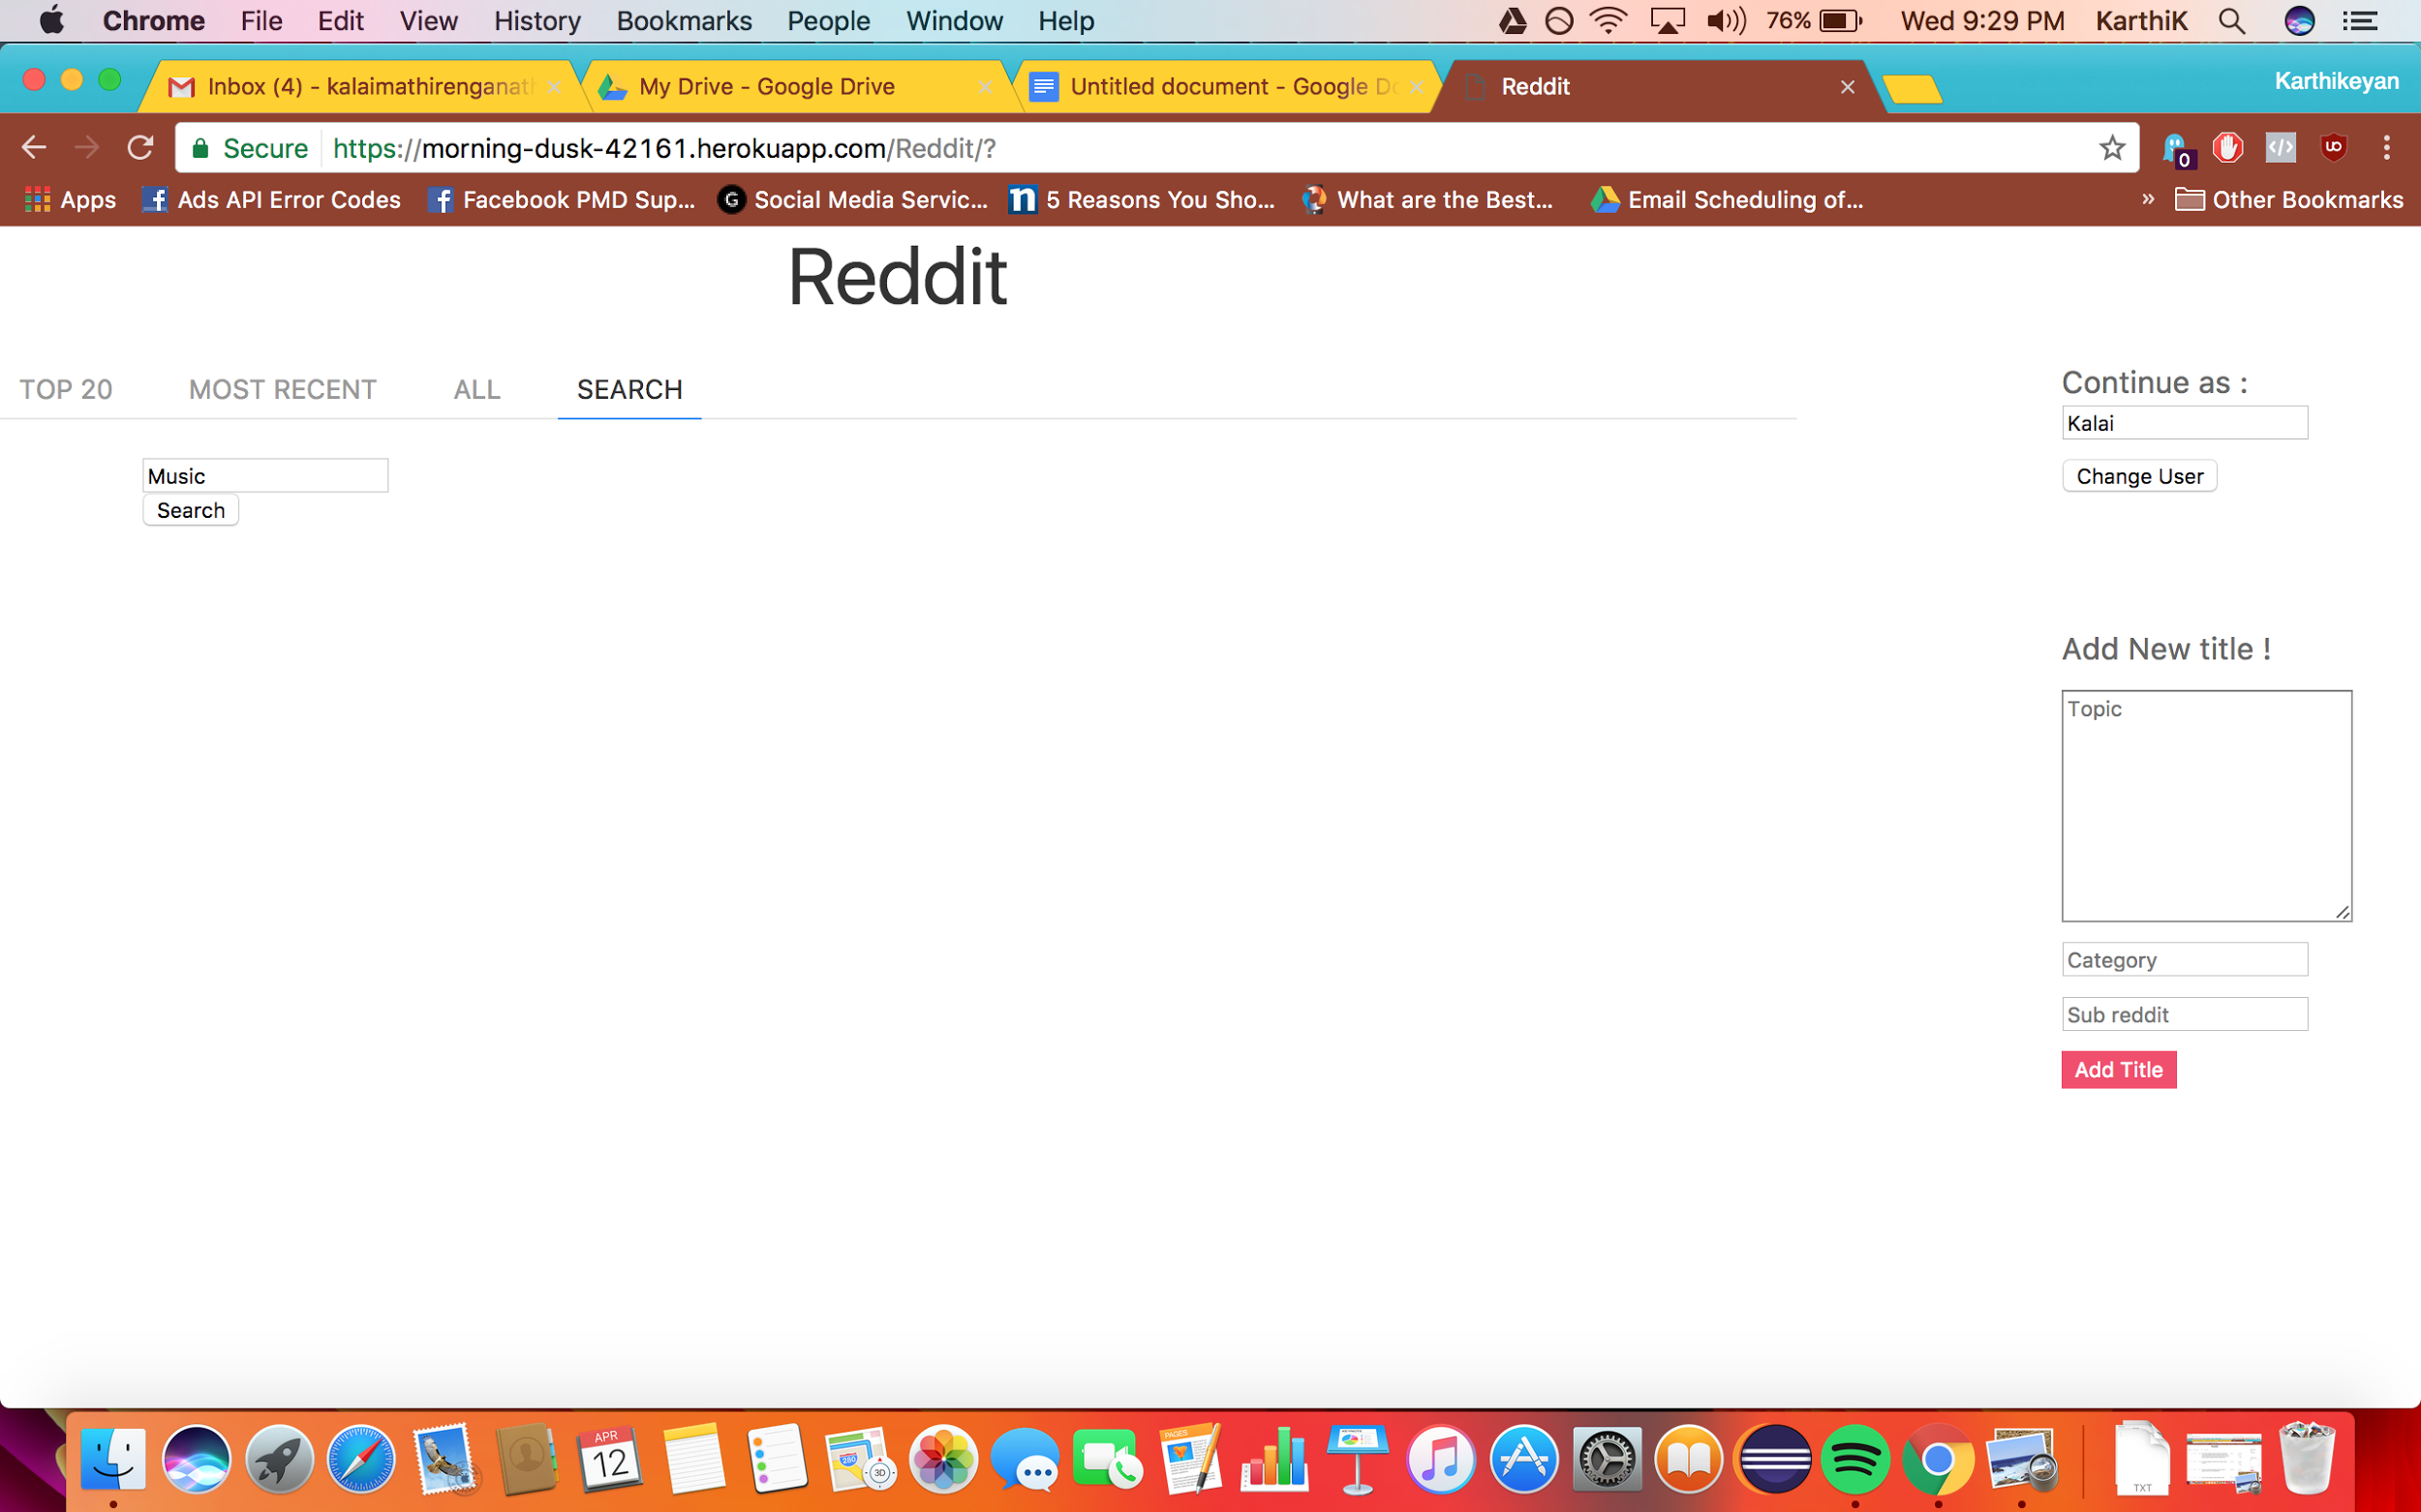

**Search results**



**Implementation:**

Developed this as an application with Python/ Django framework and NodeJS/HTML. Python dictionaries are used as in memory dictionaries to store the topics.

1. To display the top 20 - data is sorted in descending order of upvotes.
2. Topic added recently are displayed in Most recent tab.
3. All topics are displayed in ALL tab.
4. Search tab displays the form and the search results.

**Steps to run:**

1. Clone the project from the git repository:

<https://github.com/kalaimathi27/Carousell>

If you wish to run locally,

Go to the project and run : python manage.py runserver

2. The project is also hosted in Heroku in the following link:

<https://morning-dusk-42161.herokuapp.com/Reddit/>